**Monitoring Task**

Install Prometheus

- Install the below script to install prometheus

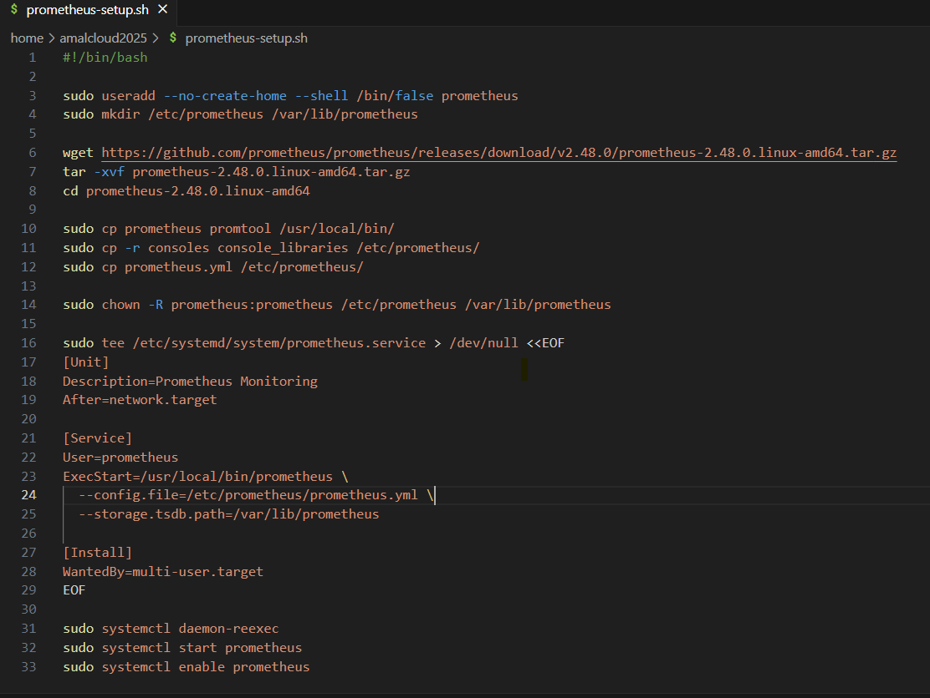

#!/bin/bash

sudo useradd --no-create-home --shell /bin/false prometheus

sudo mkdir /etc/prometheus /var/lib/prometheus

wget https://github.com/prometheus/prometheus/releases/download/v2.48.0/prometheus-2.48.0.linux-amd64.tar.gz

tar -xvf prometheus-2.48.0.linux-amd64.tar.gz

cd prometheus-2.48.0.linux-amd64

sudo cp prometheus promtool /usr/local/bin/

sudo cp -r consoles console_libraries /etc/prometheus/

sudo cp prometheus.yml /etc/prometheus/

sudo chown -R prometheus:prometheus /etc/prometheus /var/lib/prometheus

sudo tee /etc/systemd/system/prometheus.service > /dev/null <<EOF

[Unit]

Description=Prometheus Monitoring

After=network.target

[Service]

User=prometheus

ExecStart=/usr/local/bin/prometheus \

--config.file=/etc/prometheus/prometheus.yml \

--storage.tsdb.path=/var/lib/prometheus

[Install]

WantedBy=multi-user.target

EOF

sudo systemctl daemon-reexec

sudo systemctl start prometheus

sudo systemctl enable prometheus

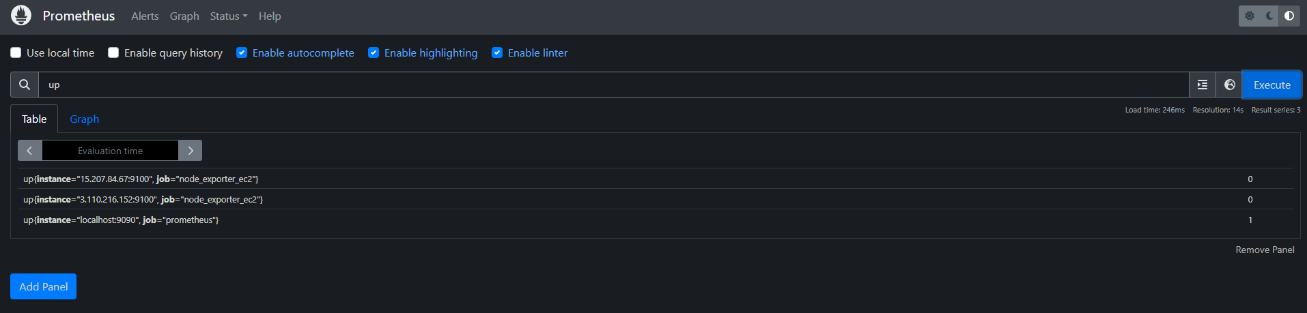

Install Grafana

- Run the below script to install grafana

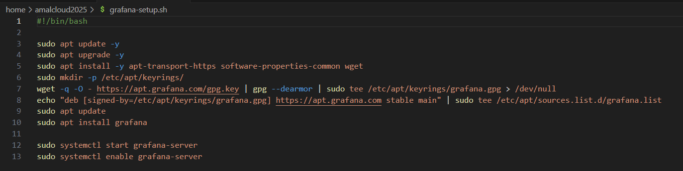

#!/bin/bash

sudo apt update -y

sudo apt upgrade -y

sudo apt install -y apt-transport-https software-properties-common wget

sudo mkdir -p /etc/apt/keyrings/

wget -q -O - https://apt.grafana.com/gpg.key | gpg --dearmor | sudo tee /etc/apt/keyrings/grafana.gpg > /dev/null

echo "deb [signed-by=/etc/apt/keyrings/grafana.gpg] https://apt.grafana.com stable main" | sudo tee /etc/apt/sources.list.d/grafana.list

sudo apt update

sudo apt install grafana

sudo systemctl start grafana-server

sudo systemctl enable grafana-server

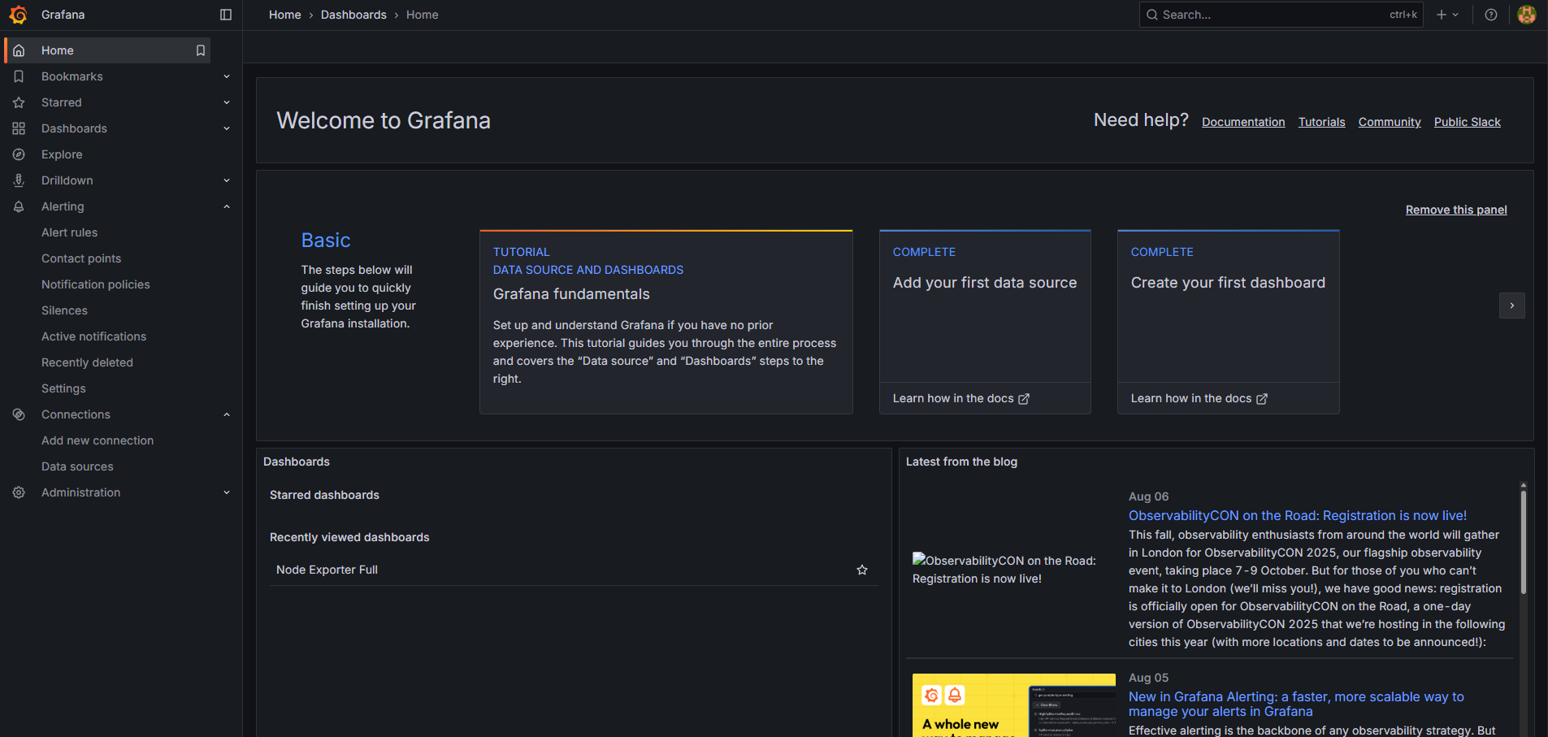

Create a EC2 Instance

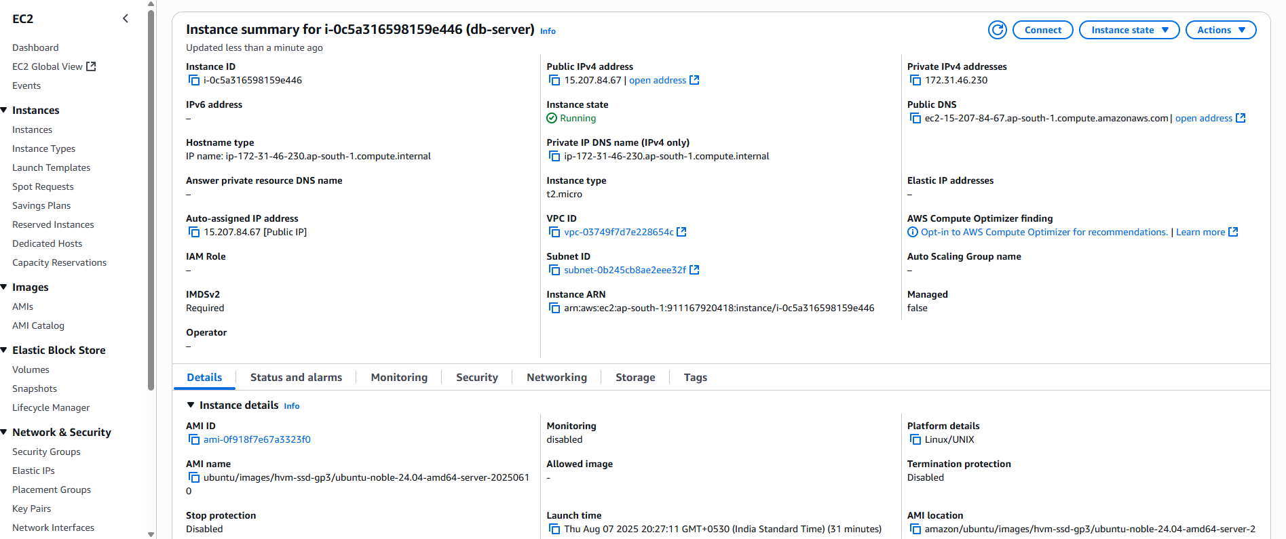

Install Node exporter

- run the below script to install node exporter

#!/bin/bash

set -e

NODE_EXPORTER_VERSION="1.8.2" DOWNLOAD_URL="[https://github.com/prometheus/node_exporter/releases/download/v${NODE_EXPORTER_VERSION}/node_exporter-${NODE_EXPORTER_VERSION}.linux-amd64.tar.gz"](https://github.com/prometheus/node_exporter/releases/download/v$%7BNODE_EXPORTER_VERSION%7D/node_exporter-$%7BNODE_EXPORTER_VERSION%7D.linux-amd64.tar.gz%22) INSTALL_DIR="/usr/local/bin" SERVICE_FILE="/etc/systemd/system/node_exporter.service"

echo "🔄 Updating system..." sudo apt update && sudo apt upgrade -y

echo "👤 Creating node_exporter user..." sudo useradd -rs /bin/false node_exporter || echo "User already exists"

echo "📦 Downloading Node Exporter v${NODE_EXPORTER_VERSION}..." wget $DOWNLOAD_URL

echo "📂 Extracting package..." tar xvf node_exporter-${NODE_EXPORTER_VERSION}.linux-amd64.tar.gz

echo "🚚 Moving binary to $INSTALL_DIR..." sudo mv node_exporter-${NODE_EXPORTER_VERSION}.linux-amd64/node_exporter $INSTALL_DIR/

echo "🧹 Cleaning up..." #rm -rf node_exporter-${NODE_EXPORTER_VERSION}.linux-amd64* #rm node_exporter-${NODE_EXPORTER_VERSION}.linux-amd64.tar.gz

echo "📝 Creating systemd service..." sudo bash -c "cat > $SERVICE_FILE" <<EOF [Unit] Description=Prometheus Node Exporter After=network.target

[Service] User=node_exporter Group=node_exporter Type=simple ExecStart=${INSTALL_DIR}/node_exporter

[Install] WantedBy=multi-user.target EOF

echo "🔄 Reloading systemd..." sudo systemctl daemon-reload

echo "🚀 Starting Node Exporter..." sudo systemctl start node_exporter sudo systemctl enable node_exporter

echo "✅ Node Exporter is running:" sudo systemctl status node_exporter --no-pager

echo "🌐 Testing metrics endpoint:" curl -s <http://localhost:9100/metrics> | head -n 10

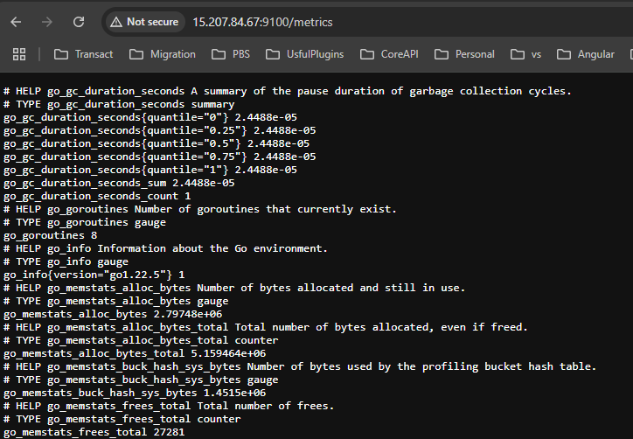

Add the EC2 IP to prometheus.yml file to start collecting the metrics

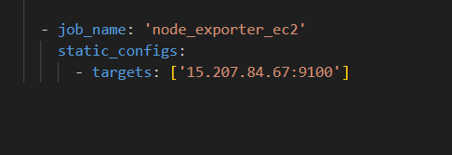

- Restart the prometheus service

- sudo systemctl restart prometheus.service

Connect Prometheus to Grafana

1. Go to **Home** **→ Connections → Data Sources**
2. Click **Add data source**
3. Choose **Prometheus**
4. Set URL: http://34.46.105.18:9090/
5. Click **Save & Test**

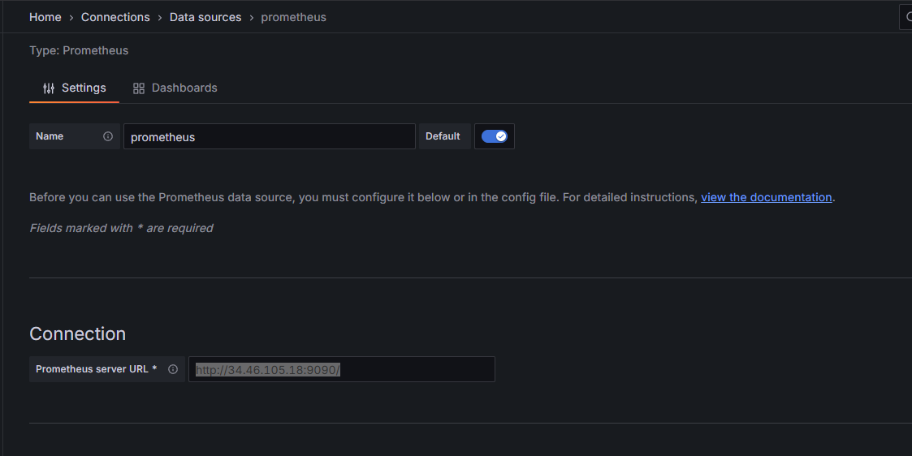

Create a Dashboard

1. Go to **Dashboards → New Dashboard**
2. Click **Import a dashboard**
3. Enter the dashboard id 1860
4. Click Load

